|  |
| --- |
| **symlogo**  COAT Requirement  And Design Doc  **By SES Regional Solution Team**  **Henry Chen** |

Contents

1 Overview 3

1.1 System Component 3

1.2 Requirement Overview 3

1.2.1 Logging in 3

1.2.2 Upload Excel files / Analyze data, Data Persistence 3

1.2.3 Approval Work Flow 4

1.2.4 Download Approved opportunity project 7

1.2.5 Upload contract scanned files 9

1.2.6 Rebate Payment Approval 9

1.2.7 Admin routine module 9

2 Page Modules 10

2.1 Login page 10

2.2 Main Menu 10

3 Database Design 11

3.1 Database Table Overview 11

3.2 Detail Table 12

# Overview

## System Component

The system is composed of

* Logging in system
* Upload Excel files / Analyze data, Data Persistence
* Approval work flow
* Download Approved opportunity project
* Upload contract scanned files
* Rebate Payment Approval
* admin routine module

## Requirement Overview

### Logging in

* Logging in system
* Logging in
* Forgot password

Log in COAT System with user account assigned by system admin role. Someone can get the random password email generated by COAT System if he forget the password, and he can change the password when he log in.

### Upload Excel files / Analyze data, Data Persistence

* Upload Excel files

ORP team will responsible to upload raw data to COAT, consolidate and first round filter and validation for partner opportunities in ORP program.

The raw data excel content format must be regular.

* Analyze data and Persistence

Action By COAT System. If SFDC Status is Resubmit / Pending Administrative Review, old data in COAT need to delete by Deal id, and then insert the new one, others insert into COAT Database directly.

Deal Size: >40K, >15K, >5K, <3K , calculated by programming code.

### Approval Work Flow

* Work Flow Chart

ORP Team

ISO Admin

Sales Operation



Channel Manager

Channel Director

Sales Team

Inside Sales

* ORP Team action: select a value from Dropdown List: **SMB** ORP / **Solution** ORP / **Dist**.
* Deal Size: >40K, >15K, >5K, <3K
* **SMB** ORP assigned by ISO Admin,

**Solution** ORP & **Dist**. ORP assigned by Sales Operation,

Auto Assignment Notification email sending to **inside sales** & **Channel Manager**

* Assign **Solution** ORP / **Dist.** ORP Opportunities to **Channel Manager** base on industry / location
* Assign **SMB** Opportunities to **Inside Sales** base on industry / location
* **Channel Manager** / **Inside Sales** Assign Sales, CC Copy Sales Director. If ORP Size > 40K, mail content need the remark: need **Cannel Director** to Approve.
* **Sales Team** Accept or no Accept with Comments, Complete Question List , notification email send to **Channel Manager** / **Inside Sales** and cc copy **Sales Team** Leader and himself.

Question List need **COAT Admin** to manage ( add / delete / update ).

IfORP Size > 40K, need **Cannel Director** to Approve.

* The Validation Result Status:

Completed, Approved / Completed, Declined / On Progress

* Operation Work Flow

Select ORP Type

ORP Team Validation

End

ISO Admin Assign to:

Sales Operation Assign to:

SMB ORP

Dist. ORP

Solution ORP

Selection on “Province-2”   
and “Industry-2”

Inside Sales

Channel Manager

Declined

Assigned wrong

Approved

Sales Team

>40K

Channel Director Validate

Declined

Validated

Approved

Declined

Assigned wrong

**Joseph input opportunity to COAT.**Joseph will make first round deal validation base on “Min. Deal Size”, “Specialization Partner List”, “If reseller in Dist. ORP deal is non-specialized reseller”, Joseph will make first round judgment click “Validated” or “Declined”, if click “Validated”, Joseph will make select ion on ORP type among “SMB ORP”, “Dist. ORP”, “Solution ORP” in Raw Data Validation Page.

Sales Operation / ISO Admin:  
1. SMB ORP assigned by Emily & Winnie: ISO Sales , needs to make selection on “Province-2” and “Industry-2” , and then, assign to inside sales, auto assignment notification email sending to Inside sales.

2. Solution & Dist. ORP assigned by Sammy to Channel Sales, Sammy needs to make selection on “Province-2” and “Industry-2” , and then, Auto Assignment Notification email sending to Channel Manager.

**Insides Sales / Channel Manager:**“Declined” or “Assigned wrong” or “Approved” with comments. If "Approved", assign to Named Account Sales (Sales List), Auto Assignment Notification email sending to name account sales and cc copy to sales leader, if “Assigned wrong”, back to up-level.

**Sales Team:**“Accept” or “Not Accept” or “Assigned wrong” with Comments, Complete Question List , notification email send to CAM/ISO and cc copy Sales Team Leader and himself. if “Assigned wrong”, back to up-level.

**Channel Director:**>40K ,additional approval step 4, must final approved by Channel Director.

Detailed workflow information, please refer the attached “ORP Workflow draft details as of Dec. 20, 2011”.

### Download Approved opportunity project

* Filter Criteria:

|  |  |  |  |
| --- | --- | --- | --- |
| ORP Type | | **Solution Specialization ORP** | |
|  | | **Distribution Specialization ORP** | |
|  | | **SMB Specialization ORP** | |
|  | | **All Specialization ORP** | |
|  | |  | |
| China Region | | **China North** | |
|  | | **China East** | |
|  | | **China South** | |
|  | | **China West** | |
|  | |  | |
|  | |  | |
| COAT Status | | **All** | |
|  | | **New** | |
|  | | **On Progress** | |
|  | | **Completed, Approved** | |
|  | | **Completed, Declined** | |
|  | |  | |
| SFDC Status | | **All** | |
|  | | **Pending** | |
|  | | **No Status** | |
|  | | **Approved** | |
|  | | **Limited Approved** | |
|  | | **Rejected** | |
|  | | **Lost** | |
|  | | **Closed** | |
|  | | **Expired** | |
|  | | **Resubmit** | |
|  | | **Pending Adminstrative Review** | |
|  | |  | |
| CAM Name | | **Drop Down List for CAM** | |
| Sales Name | | **Drop Down List for Sales** | |
|  | |  | |
| **Search by ID** | |  | |
| **Search by Customer Name** | | **模糊查询** | |
| **Search by Period** | **from** | | **date** | | **to** | **date** |

* **What kind of output is needed?**

Excel file, Detailed workflow information

### Upload contract scanned files

* **Channel Manager Upload Contract files**

Base on section 1.2.4, Channel Manager can upload Contract files, can’t delete these files, but can cover these.

### Rebate Payment Approval

* **Show Status paid or not**

Create a other new page, show the rebate payment approval status of the opportunities data according to the another raw data, if the another raw data have the data in database, so this status is “paid”, otherwise, “no paid”.

### Admin routine module

* **User Account**

Create / Update / Delete User, include search function by criteria.

* **Question List**

Create / Update / Delete Question of sales.

# Page Modules

## Login page

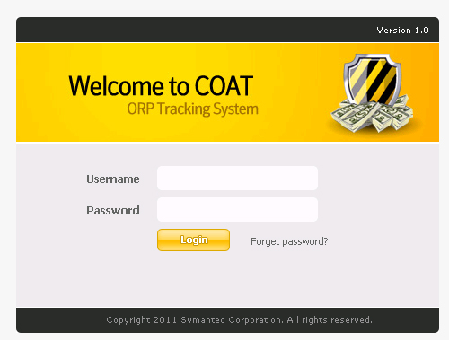

## Main Menu

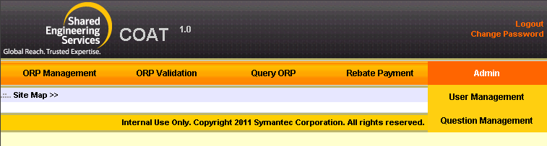

# Database Design

## Database Table Overview

Here are several tables in our database, and the usage of each table is list below:

* **ORPMaster Table**: Record the opportunities will be used approval work flow.
* **ORPTransaction Table**: Maintain the work flow, Record approval operation log.
* **ORPApproval:**, Record the name of approval.
* **ORPDealSize Table**: The price size of Opportunity. Such as: >30K, >40K etc.
* **ORPSalesQuestion Table**: The approval step 3, sales answer some questions.
* **ORPSalesAnswer:** The approval step 3, Record sales’ answer.
* **ORPStatus Table**: The approval result, such as: Completed, Approved / Completed, Declined / On Process.
* **ORPUploadFiles Table**: Uploaded files, record File name / File path / Operation User / Operation Time.
* **ORPType:**  ORP Team select ORPType among “SMB ORP”, “Dist. ORP”, “Solution ORP”.
* **SysUser Table**: Dictionary table, record the users who can operate ORP data.
* **SysTeam Table**: Dictionary table, record some team name.
* **SysRole Table**: Dictionary table. record some roles in COAT system.
* **SysIndustry Table**: Dictionary table. record the industry name.
* **SysProvince Table:** Dictionary table. record the province name.
* **SysRegion Table:** Dictionary table. record the region name.
* **SysSFDCStatus Table:** Dictionary table. record the SFDC System status.

## Detail Table

* Tables view

